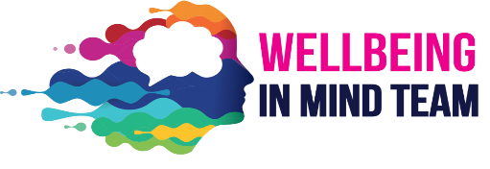

Privacy Notice

North Yorkshire, York, and Selby Wellbeing in Mind Team (WiMT)

Introduction

When you need our help and come into our service, we talk to you and the people who look after you, so we can understand your experiences and your needs, and work with you to agree a plan to help you. We write down the important things you and those who look after you tell us, and save them securely so we know what we’re doing, with who, and have a record of the work we do.

What is personal information?

The following is a list of the type of things considered to be personal information:

• Your name • Your birthday • Where you live • The name of your parents or carers. • Your doctor’s name • Why you come to see us • What we do to help you •

What do we do with it?

We keep all of your personal information safe on a secure Electronic Patient Record System that meets national safety and security standards, and can only be accessed by healthcare professionals involved in the delivery of your care.

The personal information that we collect and store helps us understand your needs, make decisions on the best treatment and care we can provide, track our progress and engagement, and keep you safe.

Who do we share your information with?

We share some personal information with your parents or carers, especially if there’s any risk that they need to support you with, but also so they can support you through your engagement with us.

If you are worried about us sharing your personal information with your parents or carers, please talk to us about it so we can understand your concerns and either support you, or work with you to make an alternative plan if this would be appropriate.

Sometimes we will share your personal information with other people involved in your care, such as your GP, school, or a social worker. If we are worried that you or someone you know is not safe, we will talk with professionals that will work with us to help keep you safe, such as our Crisis Team or the Police.

How long do we keep your information?

All NHS Trusts treating children must keep their personal information until their 26th Birthday. After this, we will destroy it, unless we feel it needs to be kept for your ongoing care or for another legitimate reason.

How do we manage anonymised information?

When your school first talks to us about you, to see if we can help, it’s always done anonymously. We keep a record of your initials, age, and gender, along with any recommendations we may make to help us, or your school, support you. We do this so we can better understand your needs, and tailor any future treatment to meet them, while providing assurances that we won’t know who you are, and wouldn’t be able to identify you without consent from either you or your parents for us to gather more information.

The anonymised information we collect is stored on our secure servers for a period of one year before being destroyed. This allows us to refer to the information during any treatment or engagement you may have with us, or review and repeat any advice if your school discusses you with us again in the future.

If you are unhappy about your care

If you are not happy with your care, or you feel concerned, unsafe or even scared, please feel that you can let us know. However, if you do not feel comfortable doing this, please speak to your teacher, parent, or carer right away, and they will know how to help you. You can tell more than one person, and everyone involved will work to support you.

If you want to know anything else

If you want to know anything else about how your personal information is managed, please email our Data Protection Officer at: tewv.dpo@nhs.net You can either contact the Data Protection Officer yourself, or you can ask a parent, carer, or teacher to support you.

If you want to see any of the personal information we hold about you, please just ask. You, or your parents or carers, can also ask to see it in writing by emailing: TEAWVNT.AccessRequests@nhs.net

If you think something is wrong with the information we have about you, either you, or your parents or carers, can contact our Data Protection Officer at: tewv.dpo@nhs.net to discuss your concerns and ask us to make any appropriate changes.

The Information Commissioner’s Office

The Information Commissioner is the person responsible for the way personal information is managed in the United Kingdom, and if you wish to make a complaint about the way we have managed your information, you can contact them using the details below:

Information Commissioner’s Office
Wycliffe House
Water Lane
Wilmslow
Cheshire,
SK9 5AF
Email: icocasework@ico.org.uk
Telephone: 0303 123 1113
Livechat on their website: www.ico.org.uk

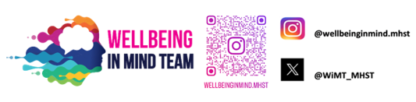

Wellbeing in Mind Team

We are a team of NHS staff working with school staff to provide advice, support and training on wellbeing issues as well as forming a link between the school and other services supporting young people. This work includes direct support for young people experiencing mild to moderate difficulties such as anxiety and low mood, support to utilise online resources and develop skills, and classroom-based education sessions in conjunction with the school’s pastoral team to improve knowledge and understanding about wellbeing.

